# The Petroglyph Inquiry

**An authentic inquiry for blind, low-vision, and sighted learners using visual and tactile images of the Sun throughout history to help evaluate a solar interpretation for a mysterious ancient rock carving.**

## Overview for Facilitators

The Petroglyph Inquiry is a standards-aligned activity designed for blind, low-vision, and sighted learners, ages 11 and up. It is guided by a web-based narrative that is screen reader friendly and accompanied by a set of seven tactile-art graphics developed by NASA PUNCH Outreach in keeping with the team’s Ancient and Modern Sun-watching theme. **Appendix D** contains professional credits for the development of the Petroglyph Inquiry.

The first of the seven graphics features a tactile representation of as sandstone petroglyph (rock carving) created by Ancestral Puebloan people who were resident in a place called Chaco [CHA-koh] Canyon a thousand years ago. The rock carving shown below is the focus of the Petroglyph Inquiry.

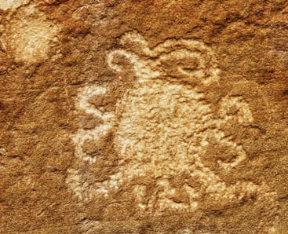

The interpretation of this mysterious petroglyph can never be known for sure, however some solar astronomers have been exploring the following hypothesis:

**The Eclipse Hypothesis:** *The ancient Chaco petroglyph represents an impression of the 1097 total solar eclipse with a solar storm in the corona.*

The other six images in the tactile set have been carefully selected to help assess the strengths and weaknesses of the eclipse hypothesis. They display diverse ways throughout history that humans have recorded the glowing outer layer of the Sun, called the solar corona. The solar corona exhibits a variety of shapes and structures, including rays, streamers, loops, and storms which make the tactile images fun, interesting, and informative to both see and touch. **Appendices A and B** introduce all of the tactile graphics and **Appendix C** tells you how to request them.

The web navigation for the Petroglyph Inquiry leads learners to read a two-page Essential Background section followed by a guided exploration of each of the seven tactile graphics in chronological order. The description and additional commentary for each image supports the learner in forming their own perspective about the eclipse hypothesis for the Chaco petroglyph. When learners have completed the Petroglyph Inquiry, they are invited to send their thoughts, ideas, and questions to the NASA PUNCH Outreach team.

While the petroglyph is certainly not the first human representation of an eclipse, it is possible that the Chaco petroglyph may be humanity’s first visual representation of a solar storm in the Sun’s corona. This is a big claim, and thus it is especially important to investigate how well the hypothesis holds up when challenged. The Petroglyph Inquiry offers learners an authentic and fun journey of learning about ancient and modern Sun-watching and exercises important standards-based skills (see **Appendix E**).

## Learning Outcomes

Participants who complete the Petroglyph Inquiry:

1. Learn to collect information and observations in support of evaluating the strengths and weaknesses of a hypothesis.
2. Understand the difference between describing and interpreting something like rock art or a shape or structure that appears in the solar corona.
3. Appreciate what the solar corona is and understand that it can only be observed when the Sun’s bright central disk is blocked.
4. Recognize the variety of ways that human beings have recorded their observations of the solar corona throughout history, from an ancient petroglyph to a contemporary coronagraph.
5. Become familiar with the basic types of shapes and features that appear within the solar corona, including rays, streamers, loops, and solar storms called Coronal Mass Ejections.
6. Become aware of the 11-year solar magnetic activity cycle and how the shape of the corona changes, depending on whether the Sun is near a maximum or minimum of sunspot activity.

## Materials:

1. Internet access
2. Laptop computer or other device for connecting with and reading from the web (for each learner)
3. **Optional:** Ear buds or headphones (for each learner if multiple learners working in same space)
4. Set of 7 thermoform tactile-art graphics (a set for each learner. See **Appendix C** for how to request).
5. Chair & tabletop space for computer and tactile graphics (Minimum is 2-ft by 2ft per learner).
6. Means of recording notes on learners’ strengths, weaknesses, questions, and ideas
7. **Optional**: Tape [for affixing labels to the tactiles or reducing slippage of tactiles on the table]
8. **Optional:** Thumbnail labels for each tactile graphic (cut out & affix to back) [see **Appendix B]**
9. **Optional:** 2.5 min podcast and 5-min video with descriptive narration. (See **References** below)
10. **Optional** download for printing available under Facilitator Resources the website

Supporting visuals for display or presentation (Each slide contains a full-size visual corresponding to one of the seven tactile graphics). [NOTE: adaptable for low-vision learners]

## Setup:

Each of the seven tactile graphics is about 9.5” wide by 10.25” tall. Each learner needs adequate tabletop space to work comfortably with a computer and the tactile graphics. There are two points in the inquiry where learners are asked to compare two of the tactile images side-by-side at one time. Learners also need access to a means of recording notes on their ideas and questions as they move through the Inquiry.

## Activity Steps:

1. Navigate to: <https://punch.space.swri.edu/punch_outreach_petroglyph-inquiry.php>. Begin reading and tracking through the Petroglyph Inquiry. Use the “NEXT” buttons at the bottom of each page.
2. Consider group discussions at the places in the tactile descriptions that are labeled “Reflection.”
3. Synthesize data from your class and/or invite individual learners to prepare a brief written or audio report on their findings regarding the strengths and weaknesses of the eclipse hypothesis for the Chaco petroglyph.
4. Send class or individual reports via email to [punchoutreach@gmail.com](mailto:punchoutreach@gmail.com) with the words “Petroglyph Inquiry Report” written in the subject line. All reports must identify the name, affiliation, and location of participating learners. Thoughtful submissions will be credited in conference presentations and a research paper about the petroglyph’s interpretation.

## Essential Background:

Learners tracking through the Petroglyph Inquiry on the website easily find the 2-page section entitled “Essential Background” by clicking the NEXT button at the bottom of the 1st page that introduces the inquiry: <https://punch.space.swri.edu/punch_outreach_petroglyph-inquiry.php>

Notice that the Essential Background section is the second item in the Navigation Bar at the top of each page of the Petroglyph Inquiry. Reading this section is an important pre-requisite for learners and their facilitators who are engaging earnestly with the Petroglyph Inquiry.

The content of the Essential Background section supports and enriches understanding of the descriptions and commentary provided for the seven tactile graphics. In particular, the section provides basic information on:

* Chaco Canyon and the Ancestral Puebloan people.
* Total solar eclipses and the Sun’s corona.
* Solar storms and the Sun’s 11-year magnetic activity cycle.

## References & Resources:

Notice that References is the next-to-last item in the Navigation Bar at the top of each page of the Petroglyph Inquiry that starts at: <https://punch.space.swri.edu/punch_outreach_petroglyph-inquiry.php>

The References section includes both academic citations that support the content of the tactile descriptions as well as resources that facilitators can use at their discretion to enrich learner experience of the Petroglyph Inquiry.

Two especially valuable resources are listed below. **Both of these are best enjoyed and most appreciated AFTER engagement with the Petroglyph Inquiry, but please be free to experiment.**

1. A 2.5-min Scientific American podcast: “Solar Eclipse in 1097 May Be Rock-Carving Subject” (18 Aug 2017) <https://www.scientificamerican.com/podcast/episode/solar-eclipse-in-1097-may-be-rock-carving-subject/>
2. A visually descriptive narration of a 5-min PUNCH Outreach video about the petroglyph (released Mar 2024) <https://punch.space.swri.edu/punch_outreach_rock-of-the-sun-in-chaco-canyon.php>

# Appendices

## Appendix A: Thermoform Tactile-Art Representations of the Solar Corona

The PUNCH Outreach team developed the set of seven thermoform tactile-art representations of the solar corona used for the Petroglyph Inquiry in collaboration with blind learners, educators, solar scientists, and tactile artist Dr. Nicole Johnson. Dr. Johnson’s PhD dissertation at the University of Colorado included working with the PUNCH Outreach team on the design and fabrication of our tactile graphics. In addition to the Chaco petroglyph, the set includes an 1860 hand drawing, a 1918 painting, and a pair of contemporary ground-based photographs, all made during the totality phase of a solar eclipse. A pair of spacecraft images made with a NASA coronagraph completes the current set of seven.

**A collage of pictures. At left, a blind learner is comparing two versions of the petroglyph tactile. To the right of this are two rows of images. The top row shows three visuals (a spacecraft image, a hand drawing, and the Chaco petroglyph). The bottom row shows the corresponding tactile images created by PUNCH Outreach in collaboration with Dr. Nicole Johnson. 
**The collage of images below displays three of the seven images and their corresponding thermoform tactile-art representations. At left is an image of a learner from the Colorado Center for the Blind who helped to compare early prototypes of the Chaco petroglyph so we could determine the best way to represent it.

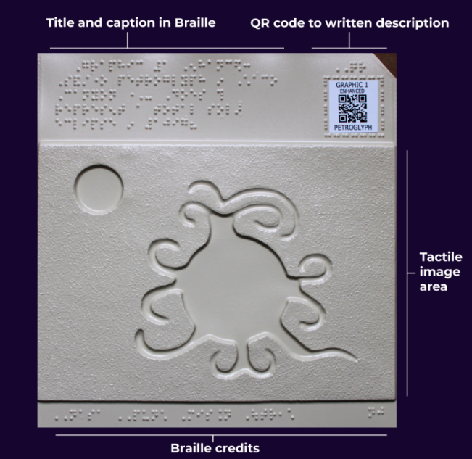The labeled image reveals the consistent layout for each of the seven tactile graphics. The tactile-art image for the Chaco petroglyph is sandwiched in between a Braille title at the top and Braille credits at the bottom. ***It is NOT required to read Braille to participate in this activity so long as the web-based text descriptions for each tactile graphic can be accessed via screen-reader or other means.*** A QR code at the upper right leads directly to the web-based description for the particular tactile. The navigation bar at the top of each web page allows the user to find their way to the Petroglyph Inquiry from any of the individual tactile graphics.

## Appendix B: Thumbnails for the PUNCH Outreach Thermoform Tactile-Art Graphics

**Email Contact:** [punchoutreach@gmail.com](mailto:punchoutreach@gmail.com) **Version Date**: *July 2024*

***NOTE:*** *The next pages contain a thumbnail for each of the seven Graphics (1, 2, 3, 4a, 4b, 5a, and 5b) used for the Petroglyph Inquiry. Each thumbnail includes the title as it appears in Braille on the Graphic, and the image being represented on that Graphic. To support communication among sighted and blind learners and facilitators, the thumbnail pages can be copied and cut out along the horizontal lines across the page at “*CUT HERE*.” The strips can be affixed to the back of the thermoform Graphics.*

CUT HERE = cut horizontally along this line of text to make visual thumbnails for the Graphics

**Graphic 1:** Sandstone petroglyph in Chaco Canyon

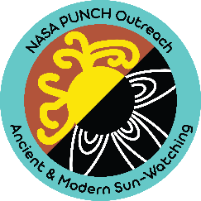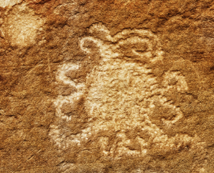Does this represent a total solar eclipse in **1097?**

CUT HERE = cut horizontally along this line of text to make visual thumbnails for the Graphics

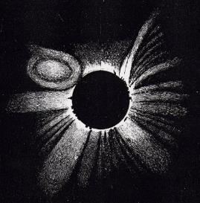**Graphic 2: 1860** Hand drawing of total solar eclipse with a solar storm in the Sun’s corona

CUT HERE = cut horizontally along this line of text to make visual thumbnails for the Graphics

**Graphic 3: 1918** Painting of total solar eclipse during a time of solar maximum

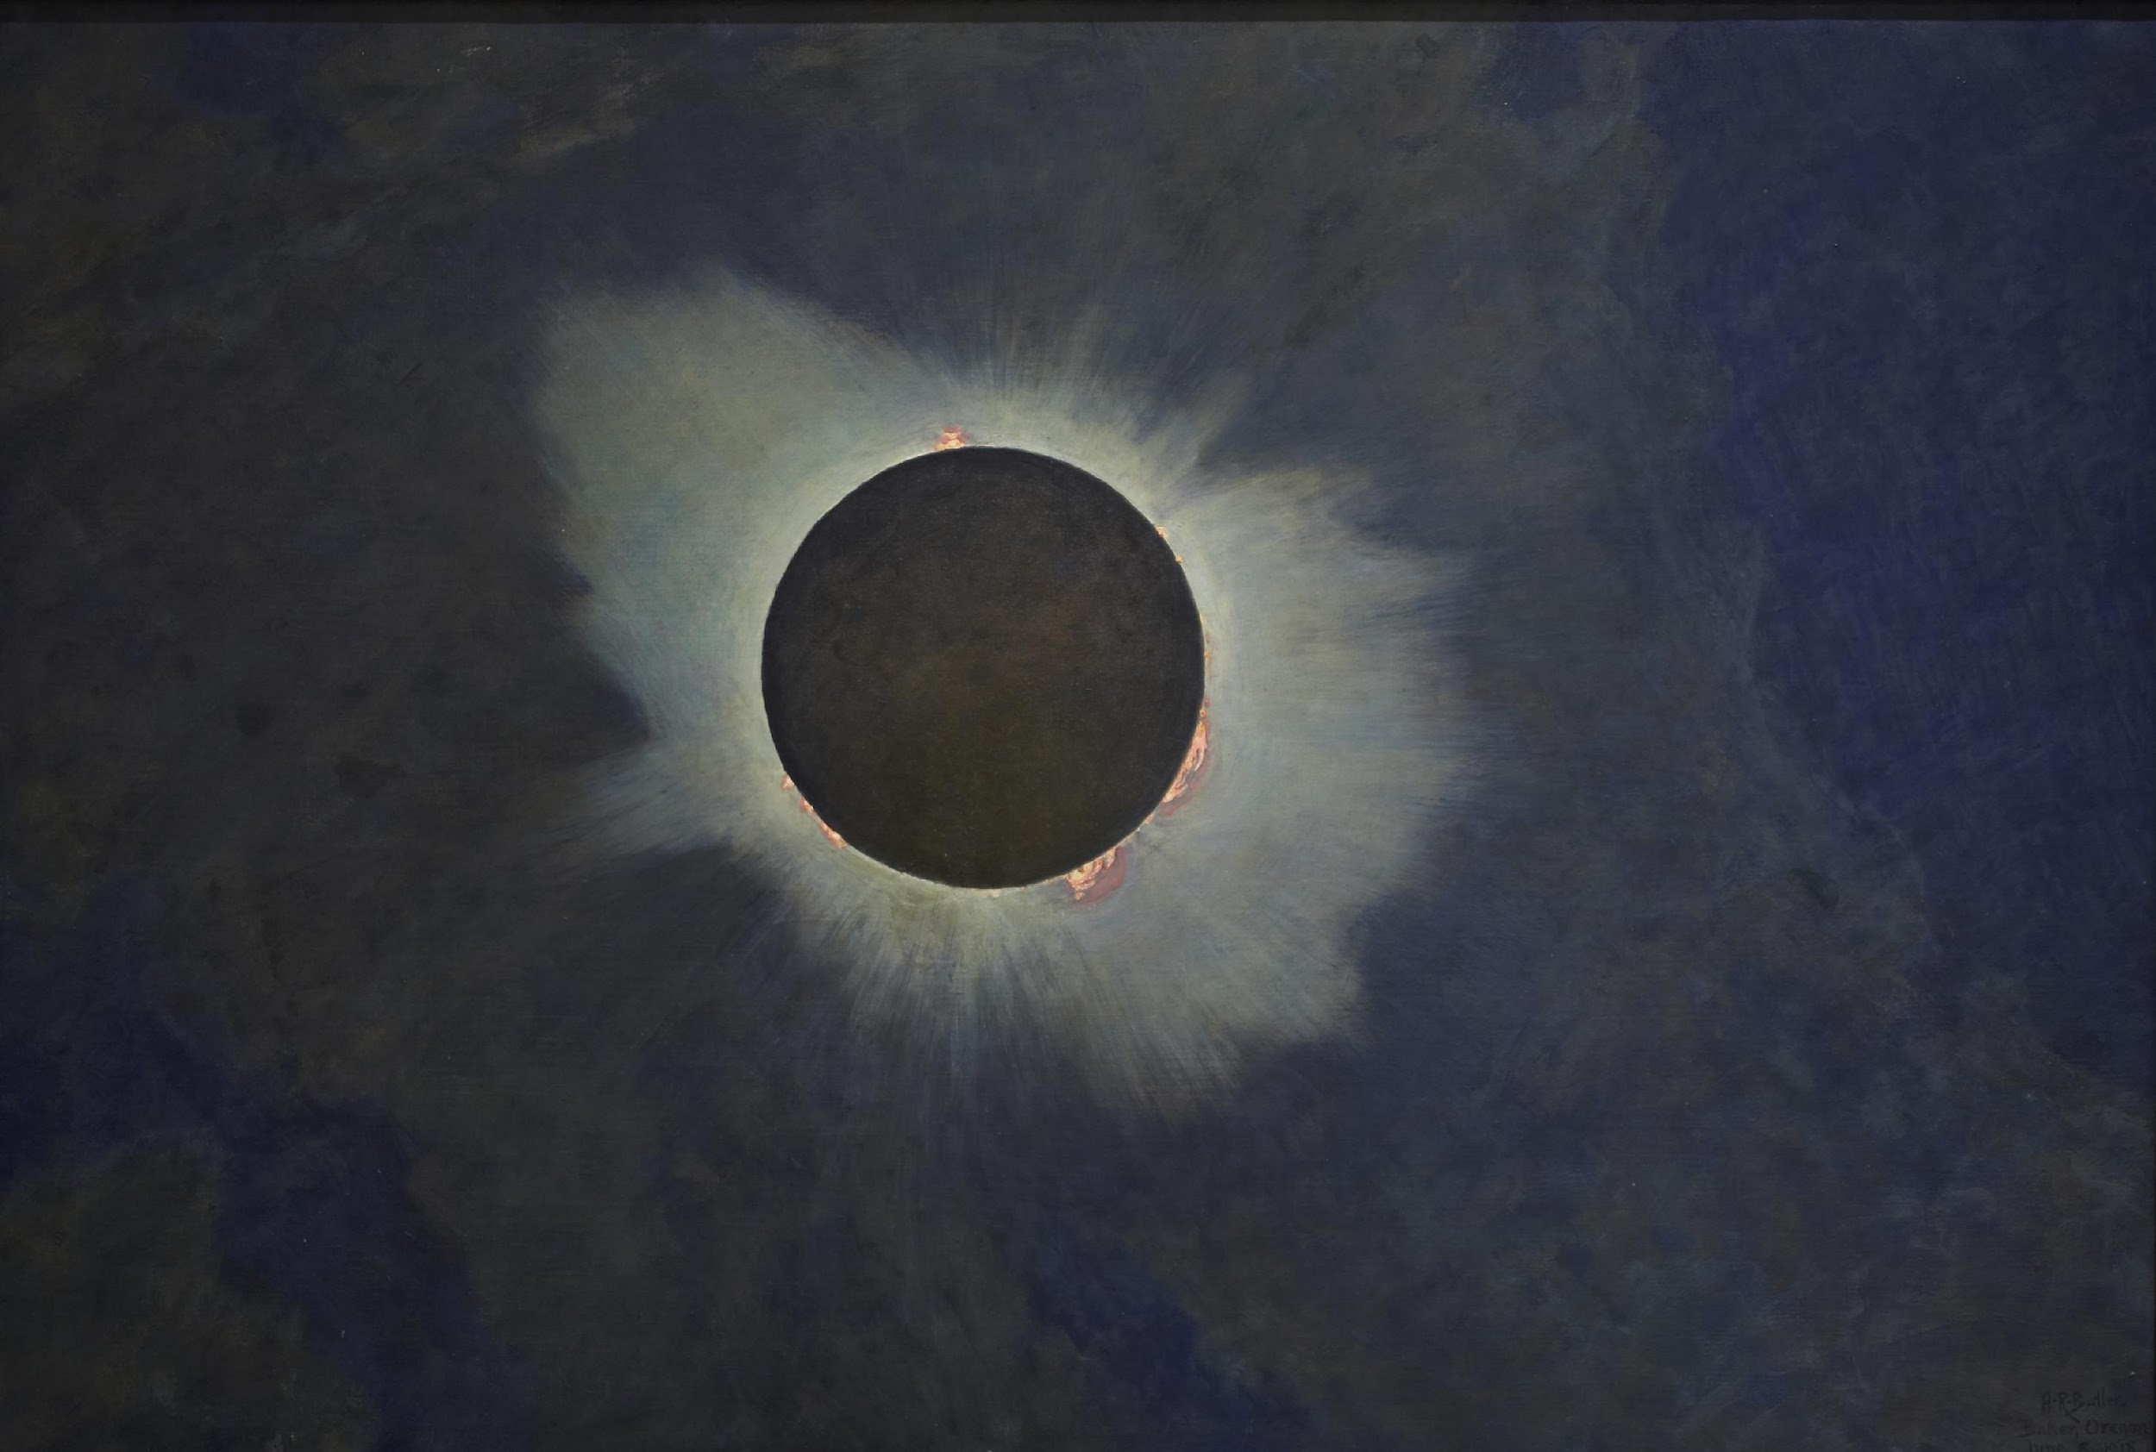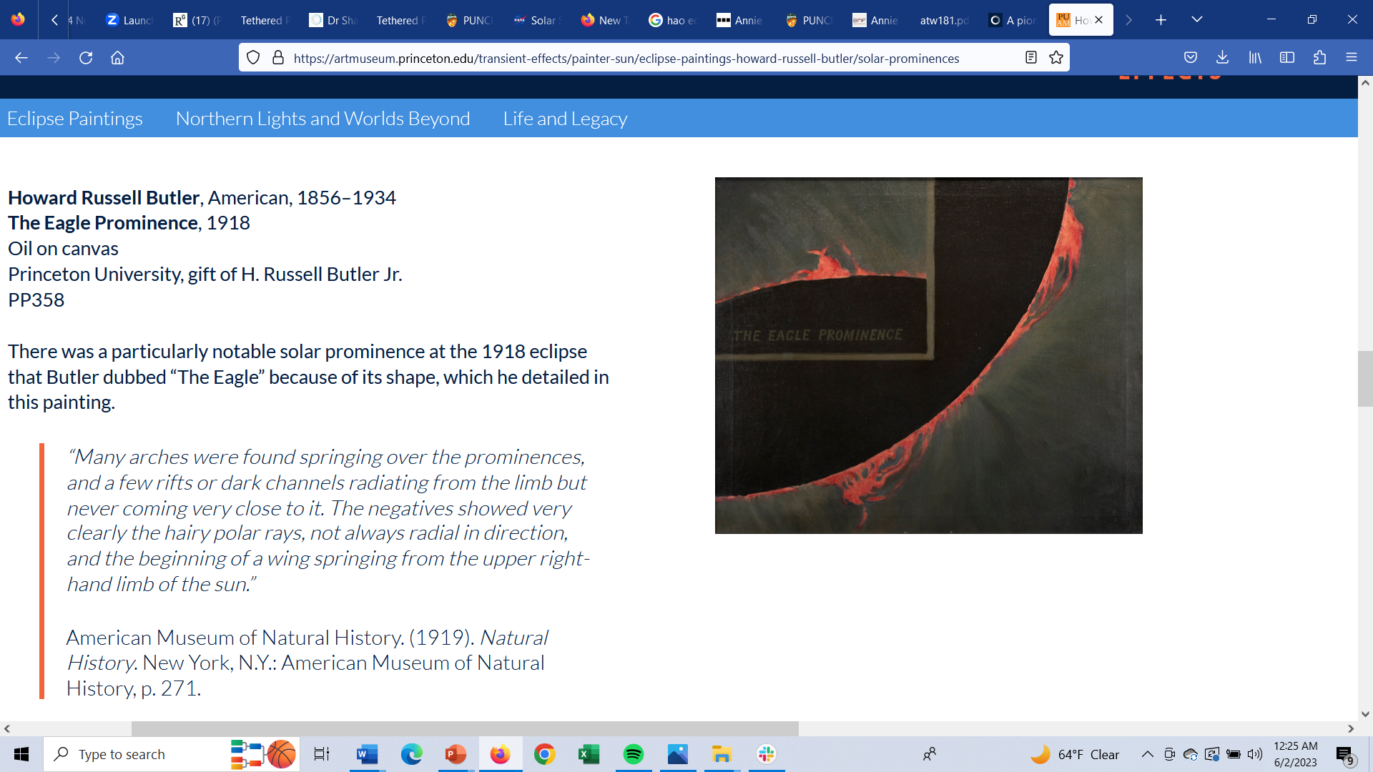

CUT HERE = cut horizontally along this line of text to make visual thumbnails for the Graphics

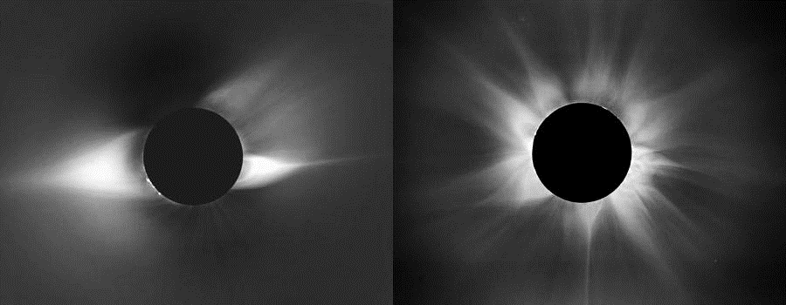**Graphic 4a**: **1980** Ground-based photograph of total solar eclipse during a time of solar maximum

CUT HERE = cut horizontally along this line of text to make visual thumbnails for the Graphics

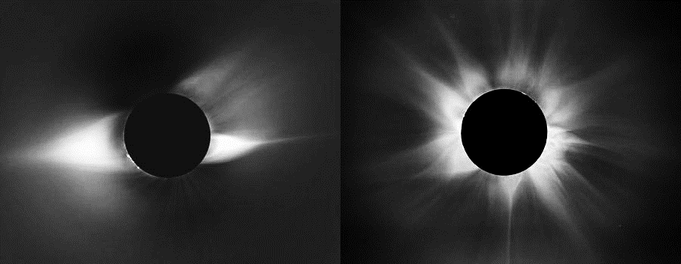**Graphic 4b**: **1994** Ground-based photograph of total solar eclipse during a time of solar minimum

CUT HERE = cut horizontally along this line of text to make visual thumbnails for the Graphics

Thumbnail of visual represented in tactile Graphic 5a: 1996 NASA spacecraft image during time of solar minimum. Rays of the outer solar corona extending out to the sides from a central disk that is larger than the Sun's disk.

**Graphic 5a**: **1996** NASA spacecraft image using an occulting disk to mask the Sun and reveal its outer corona during a time of solar minimum

CUT HERE = cut horizontally along this line of text to make visual thumbnails for the Graphics

**Graphic 5b**: **2000** NASA spacecraft image using an occulting disk to mask the Sun and reveal its outer corona with two solar storms during a time of solar maximum

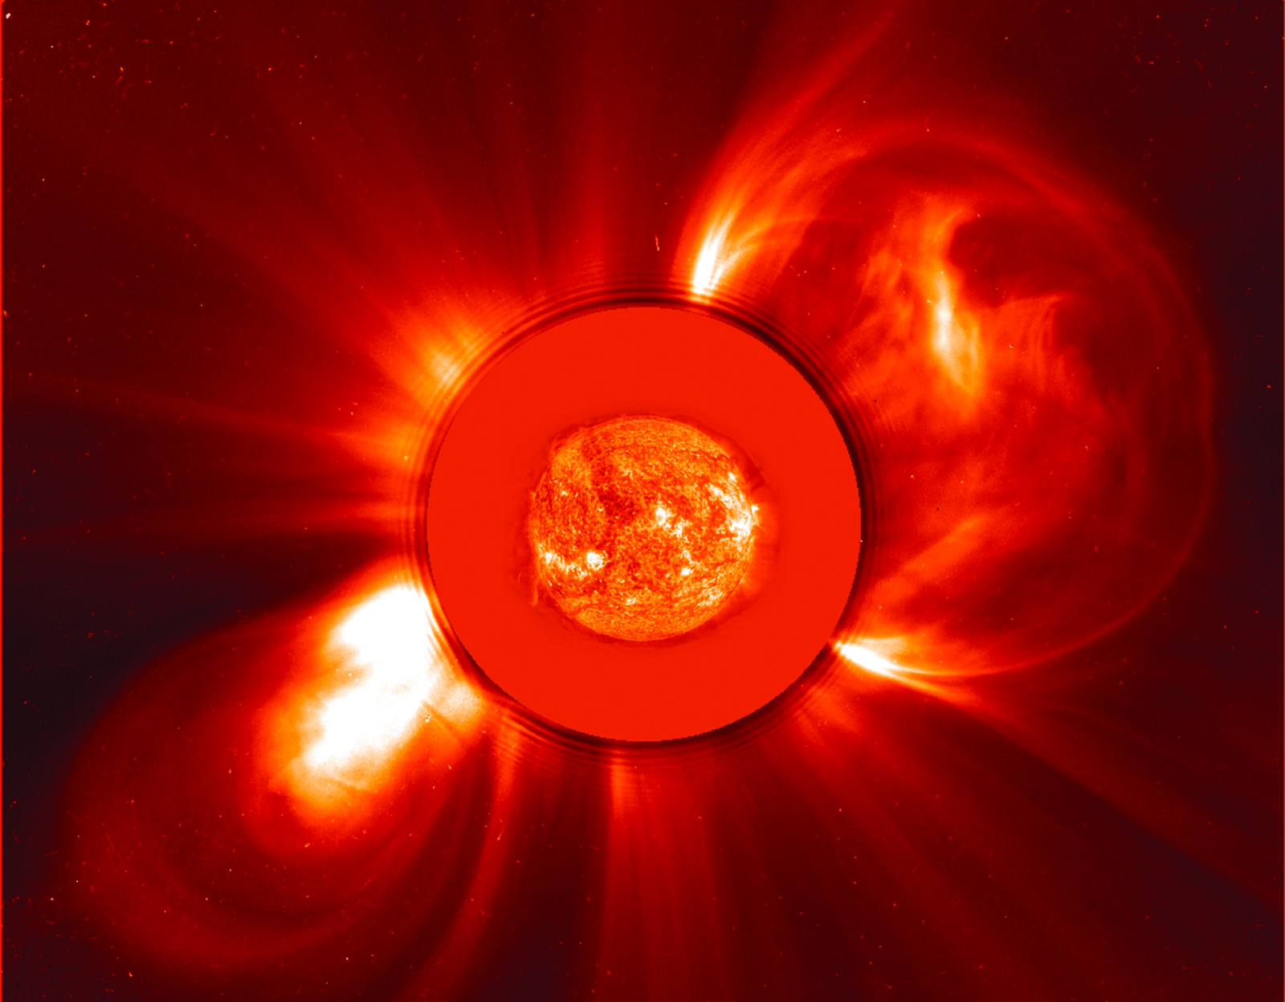

## Appendix C: How to Request the Set of Seven Thermoform Tactile-Art Graphics

PUNCH Outreach is working on a means for our set of tactile-art graphics to become more universally available to the community in a sustainable way.

Meanwhile, please request the tactile graphics by sending an email to [punchoutreach@gmail.com](mailto:punchoutreach@gmail.com) with the words “Petroglyph Inquiry Request” in the Subject Line and the following information in the body of the message:

1. Name
2. Email address & phone
3. Shipping address
4. Date on which you want your tactiles to arrive
   * 1. **NOTE:** If we do not have tactiles in stock at the time of your order, please allow up to four weeks for new inventory to be created
5. Number of *sets of seven* tactile graphics being requested
   * 1. **NOTE:** This number is limited to two unless further justified in your description of context below. Preference is given to those outfitting classrooms or workshops with blind learners to do the Petroglyph Inquiry. In this case, shipping ten or more sets is possible, especially if the sets will be re-used with blind learners,
6. Description of the context in which you intend to use the tactile graphics
7. Agreement to provide feedback on your experience using the tactile graphics

## Appendix D: Credits for the Petroglyph Inquiry

### Lead Author & Creative Director

Cherilynn Morrow, PhD

Outreach Director, NASA PUNCH Mission (and Volunteer Interpreter & Researcher in Chaco Canyon)

Education & Diversity Consultant, Southwest Research Institute, Boulder, CO

### Key Collaborators:

**STEM Education for Blind and Low-Vision Learners (co-author)**

Tasnim Alshuli, PhD Candidate, University of Arizona, Tucson, AZ

**Web Development (co-author)**

Don Kolinski,

High Altitude Observatory, Boulder, CO

**Tactile-Art Design & Fabrication**

Nicole Johnson, PhD  and John M. Keller, PhD

Fiske Planetarium, University of Colorado, Boulder

Faculty and Students at the Colorado Center for the Blind

### Key Advisors:

**STEM Education for Puebloan Learners**

Joe Aragon, Tribal Member, Pueblo of Acoma, NM

**STEM Education for Navajo and Blind and Low-Vision Learners**

Garrison Tsinajinie. Clinical Faculty, University of Arizona, Tucson

**STEM Education Research for Historically Marginalized Populations**

Joelle LeMer, Northern Arizona University, Flagstaff, AZ

### Key Reviewers:

**Pedagogy of Inquiry**

Mike Zawaski, PhD, Fort Lewis College, Durango, CO

**Chaco Canyon Interpretation**

David Cornucopia. Chaco ranger, NPS retired

### Key Field Testers:

**Field testing of Tactiles with Blind Learners in Tucson, AZ**

Lila Hunter-Reay (while a master’s degree student at the University of Colorado)

Sanlyn Buxner, PhD. University of Arizona, College of Education (PUNCH Outreach Evaluator)

**Field testing of Tactiles with Neurodiverse Museum Visitors**

Jayne Aubele, New Mexico Museum of Natural History and Science, Albuquerque, NM

## Appendix E: Connections to the Next Generation Science Standards

The Petroglyph Inquiry is strongly aligned with the foundational principles and content of the Next Generation Science Standards. The Framework on which the standards are based requires students to learn how to operate at the intersection of three dimensions of learning:

* Science and Engineering Practices (Appendix F)
* Crosscutting Concepts (Appendix G)
* Disciplinary Core Ideas (ESSS1.B)

The Petroglyph Inquiry offers learners the opportunity to interweave these naturally. The relevant Disciplinary Core Ideas derive from *ESSS1.B Earth and the Solar System*. Learners engage with the relationship among the Sun, Moon, and Earth that leads to solar eclipses. The emphasis on solar cycles and solar storms is an integral part of the Petroglyph Inquiry and this brings authentic consideration to three of the seven Crosscutting Concepts: observing patterns, flows and cycles, stability, and change.

The Petroglyph Inquiry is especially rich in Science Practices with opportunities to exercise at least five of the eight cited in the NGSS. These are: asking questions, analyzing, and interpreting data, constructing explanations, arguing from evidence, and obtaining, evaluating, and communicating information.

A major idea in the Petroglyph Inquiry is the progression of technology and science throughout time (Appendix J). The set of seven tactile graphics demonstrate how human beings have learned to record the solar corona through time from the Chaco petroglyph (possible), to hand drawing, to painting, to ground-based photography, to space-based imaging. Each new approach brings additional perspective and capability for new scientific understanding. This becomes evident as the learner explores historical and contemporary images of the Sun’s corona made with increasingly sophisticated technology in order to assess strengths and weaknesses of the “eclipse hypothesis” for the ancient Chaco petroglyph.

National Academies of Sciences, Engineering, and Medicine. 2012. A Framework for K-12 Science Education: Practices, Crosscutting Concepts, and Core Ideas. Washington, DC: The National Academies Press. https://doi.org/10.17226/13165.